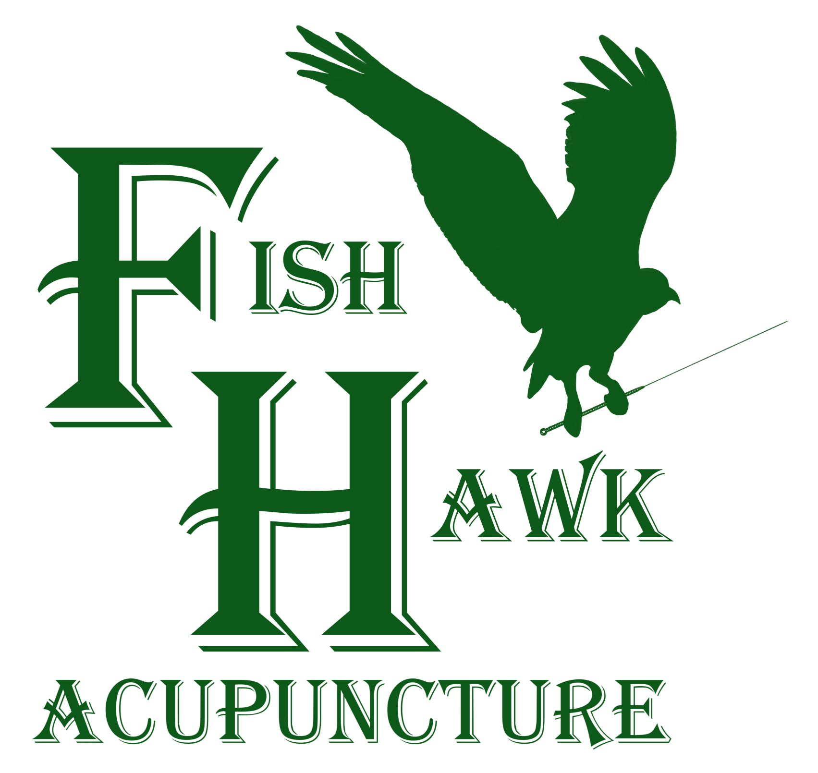

Consent to Treatment

By signing below, I consent to treatment with acupuncture and other procedures within the scope of practice of Oriental Medicine. These modalities include, but are not limited to, acupuncture, herbal medicine, nutritional supplements, moxibustion, cupping, electrical stimulation, Shonishin, Tui-Na, and low-level laser therapy.

Acupuncture: I understand that acupuncture includes the insertion of needles through the skin at determinable points on or near the surface of the body. While acupuncture is generally safe, some adverse side effects may result. These may include but are not limited to, local bruising, pain or discomfort, minor bleeding, dizziness, fainting, and the possible aggravation of existing symptoms. I understand that I am free to stop acupuncture treatment at any time.

Herbal Remedies and Nutritional Supplements: Herbal remedies and nutritional supplements are often recommended as part of treatments. I am aware that if I decide to accept these treatments, all prescriptions must be prepared and administered as instructed. I understand that adverse side effects may result from taking these substances. These may include but are not limited to, abdominal pain or discomfort, nausea or vomiting, headaches, changes in bowel patterns, and the possible aggravation of existing symptoms. If any issues, associated with these substances, occur, I should stop taking them and contact the doctor as soon as possible.

Tui-Na, Shonishin, Gua Sha, Cupping: All of these treatments include rubbing, pulling, pressing, or tapping various parts of the body. These techniques may result in adverse side effects including but not limited to, bruising, redness, sore muscles or aches, and the possible aggravation of existing symptoms. I understand that I may stop treatment if it is too uncomfortable.

Low-Level Laser Therapy: Low-level laser therapy is used to stimulate acupuncture points, promote healing of wounds, reduce inflammation, and skin issues. There are no known side-effects with low-level laser therapy when appropriately used.

Moxibustion: Moxibustion involves burning the herb mugwort (Artemisia vulgaris) to warm various parts of the body. I understand that if I receive moxibustion, there is a risk of sensitivity to the smoke, burns, scarring, and allergic reaction

Electro-Acupuncture: I understand that I may be asked to have electro-acupuncture administered with the acupuncture. I am aware that some adverse side effects may result. These include but are not limited to electrical shock, pain or discomfort, and the possible aggravation of existing symptoms.

Acupoint Injection Therapy: I understand acupoint injection therapy involves the injection of herbs, homeopathic remedies, and other nutritional supplements into acupuncture points via hypodermic needles. I am aware that certain adverse side effects may result from this treatment. These include but are not limited to, pain, mild bleeding, redness, swelling or numbness around the injection site, muscle stiffness, fatigue, diarrhea, mild to severe allergic reactions, and possible aggravation of existing symptoms.

Other Risks: I understand that while this document describes the significant risks of treatment, other side effects and risks may occur. While I do not expect the clinical staff to be able to anticipate and explain all possible risks and complications of treatment, I wish to rely on the practitioner to exercise judgment during treatment which, the practitioner thinks at the time, based upon the facts then known, is in my best interest. I understand that, as with all healthcare approaches, results are not guaranteed, and there is no promise to cure.

Condition Disclosure: I understand that I must advise the practitioner if I have a pacemaker, cardiac condition, bleeding disorder, history of seizures, am currently on blood thinners (Coumadin, Warfarin, etc.), or if I am or may be pregnant. I must also inform, and continue to update, the practitioner of any medical history, family history, medications, or supplements currently taken (prescription and over-the-counter).

Alternative Options: I understand that there may be other treatment alternatives, self-administered care, over-the-counter pain relievers, physical measures and rest, allopathic medical care with prescription drugs, physical therapy, bracing, injections, and surgery.

Acknowledgment: I have carefully read and understood all of the above information and am fully aware of what I am signing. I may ask my practitioner for a more detailed explanation if needed. I give my permission and consent to treatment.

Patient Name:
(Printed)
Patient Signature:
(Or Patient Representative)
Relationship if signing for the patient

